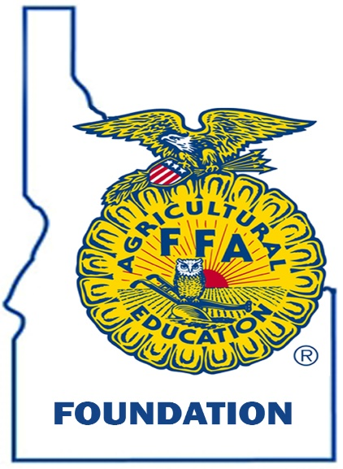
Moscow State Contests
Scholarship
June 1st-6th , 2025

The Moscow State Contests are held at the University of Idaho. Members compete in Career development events, which are activities that allow students to learn more about agricultural areas they are interested in. That knowledge is put to the test when students get the opportunity to challenge themselves in industry-based competency exercises in a variety of agriculture and leadership scenarios.

Scholarship Eligibility Requirements and Specifics:
- All scholarship applicants must be a current student and a member in good standing with their local FFA chapter.
- All applications are required to make a team and attend all the practices.
- Please type your application.
- Scholarship applications must be completed, including required signatures, Before May 13, 2025. Please bind the application by simply stapling in the top left-hand corner. Please do not place application in a presentation folder.
- Scholarship finalists will be notified by May 14th.

Scholarship Awards:
- Registration fee
- Cost of room

(PLEASE BRING MONEY FOR FOOD & OTHER ACTIVITIES.)

Name:___________________________________________________
Address:_________________________________________________
Grade:___________________________________________________
Phone Number:___________________________________________
1. Write a short biography about your goals in FFA, your SAE, and your future plans in our chapter.

3. What Career Development Events (CDE’s) can members participate in at Moscow?

4. What CDEs do you plan on competing in at Moscow? List all of the different parts of that/those contests.

5. Going to Moscow, you must make a team. How will you benefit the team that you are on?

6. This is a need-based scholarship, please explain in detail why you need this scholarship to go to Moscow. (Advisors are the only ones that read this application)

I, the undersigned applicant do hereby certify that information contained in this application is true and accurate to the best of my knowledge.

Typed or printed name of applicant:

Signature of applicant:

I/We, the undersigned parents/guardians do hereby support our son/daughter in their efforts to attend Moscow State CDE’s and do hereby certify the information contained in this application is true and accurate to the best of my/our knowledge.

Typed or printed name of parent/guardian:

Signature of parent/guardian:

